Matthew F. Wasson, Ph.D.,
Director of Programs
Appalachian Voices

Testimony on "Effect of President's FY 2013 Budget and Legislative Proposals for the Office of Surface Mining on Private Sector Job Creation, Domestic Energy Production, State Programs and Deficit Reduction" before the House Committee on Natural Resources, Subcommittee on Energy and Mineral Resources

March 6, 2012

Thank you Chairman Lamborn and members of the Subcommittee for the opportunity to speak about the need for OSM to implement an effective Stream Protection Rule. I also appreciate the opportunity to counter the alarmist misinformation that has surrounded the debate about the SPR in regard to the rule's purported threats to jobs and the economy.

My name is Matt Wasson and I am the Director of Programs at Appalachian Voices, a non-profit organization dedicated to addressing the greatest environmental threats to the Southern and Central Appalachian Region. Appalachian Voices is a member of the Alliance for Appalachia, which is an alliance of 13 grassroots organizations working to end mountaintop removal coal mining and bring a just and sustainable future to Central Appalachia.

Beginning with my doctoral research at Cornell University on the impacts of acid rain on birds, I have spent the last 17 years involved in research on the mining, processing and combustion of coal. Despite my extensive research on stream ecology and coal, I can't offer the subcommittee the type of testimony that would be most salient to the topic of today's hearing - the tragic personal stories of what it is like to bathe your children in polluted water or to wake up one day to find your tap water looks like tomato soup and smells like rotten eggs. But through my work with the Alliance for Appalachia I have had the privilege of working with many people who have experienced precisely those circumstances. On their behalf, I will try to provide my best summary of the myriad and devastating impacts that poorly regulated coal mining can have on nearby families and communities.

The most damaging form of poorly regulated coal mining is mountaintop removal, a technique that involves blasting off the tops off mountains to access thin seams of coal and then generally dumping the waste and debris into nearby valleys. Not only has this practice obliterated more than 500 of the oldest and most biologically diverse mountains on the continent, but it has buried more than 2,000 miles of streams and polluted the headwaters of the drinking water supply of millions of Americans.

More importantly, 18 peer-reviewed scientific studies have linked mountaintop removal and other forms of coal mining to a host of medical conditions including increased rates of birth defects, cancer and cardiovascular disease in nearby communities, resulting in life expectancies comparable to those in developing countries like Syria, Iran and Viet Nam.

Despite what you may have heard, the controversy over the Stream Protection Rule is all about mountaintop removal. The atmosphere of confusion, misinformation and near hysteria surrounding OSM's development of that rule was initiated and fueled by those with a vested interest in continuing and even expanding the practice.

As the chairman and members of this committee know well, an early discussion draft of the environmental impact statement for the Stream Protection Rule was leaked to coal company employees and the media just over a year ago. While mountaintop removal supporters quickly took advantage of the opportunity to spread fear and misinformation about the rule (i.e., asserting that it would abolish western surface mining and longwall mining in the East), the actual content of the leaked EIS provides no indication that OSM has any such intentions. To provide some perspective, the three most restrictive regulatory alternatives evaluated in the draft EIS were predicted to lead to increased underground coal mining in the East, while the fourth alternative would have no impact. I would guess that this fact has not been brought up by coal industry witnesses in this committee.

Like most advocates for a strong Stream Protection Rule, I recognize that America needs coal to power our homes, factories and economy. Moreover, we will continue to rely on the hard work and sacrifice of American miners to supply coal for years, perhaps decades, into the future. While demand for coal is in long-term decline due to competition from other energy sources, there is no immediate alternative that can replace the 42% of our electricity and 20% of our overall energy supply that coal currently provides. The best way to ensure a reliable supply of coal, as well as to honor the men and women that mine it, is to give agencies the authority and resources they need to ensure coal is mined in a manner that does not destroy the land, water and health of nearby residents and that clearly complies with laws passed by Congress to protect our natural resources.

On behalf of the thousands of people whose health, homes and communities are at risk from poorly regulated mining practices in Appalachia and beyond, I implore the members of this committee to allow OSM to do its job to promulgate common sense rules that will protect the people and mountains of Appalachia as well as the streams that are the headwaters of the drinking water supply of millions of Americans.

Why a Strong Stream Protection Rule is Necessary

Environmental Considerations
The fact that surface coal mining, and mountaintop removal mining in particular, is causing massive and irreversible impacts to Appalachian streams is beyond question. According to a groundbreaking study published by 13 leading aquatic ecologists in 2010 in Science, the nation's premier scientific journal:

"Our analyses of current peer-reviewed studies and of new water-quality data from WV streams revealed serious environmental impacts that mitigation practices cannot successfully address. Published studies also show a high potential for human health impacts... Clearly, current attempts to regulate [mountaintop removal mining] practices are inadequate. Mining permits are being issued despite the preponderance of scientific evidence that impacts are pervasive and irreversible and that mitigation cannot compensate for losses."

In addition to the impact on streams, mountaintop removal has obliterated 500 of the oldest mountains on the continent and caused widespread destruction and fragmentation of Appalachian forests. According to the 2010 Science article, "The extensive tracts of deciduous forests destroyed by [mountaintop removal] support some of the highest biodiversity in North America, including several endangered species."

Impacts on the Health and Well-Being of People
There's a common saying in Appalachia: what we do to the land, we do to the people. A host of recent peer-reviewed scientific studies have demonstrated the truth of these words. Evidence of pervasive impacts on the health, well-being and life-expectancy of people living near mountaintop removal and other types of coal mines in Appalachia has been published over the last five years in 18 different scientific studies authored by nearly 40 different researchers. This overwhelming evidence led the Kentucky Medical Association to pass a resolution in 2011 pledging to "educate the public and make publicly visible its support for national and state laws, rules and regulations that protect individual health and public health from the impact of the extraction, transportation, processing and combustion of coal." As reasons for adopting the policy, the KMA made the following statements

- "A recent study found that the loss of stream integrity from valley fills associated with mountaintop removal (MTR) coal mining is related to increased cancer mortality;"
- "A recent study found elevated birth defect rates in MTR areas of central Appalachia compared with other coal mining areas and non-mining areas;"
- "MTR areas are also associated with the greatest reductions in health-related quality of life even when compared with counties with other forms of coal mining;"
- "Considering the value of life lost, a 2009 study concluded that the human cost of the Appalachian coal mining economy outweighs its economic benefits."

In addition to the health impacts cited by the Kentucky Medical Association, recently published studies have associated mountaintop removal and other forms of coal mining in Appalachia with increased rates of:

- Chronic respiratory and kidney disease,
- Low birth weight,
- Deaths from cardiopulmonary disease,
- Hypertension,
- Lung cancer,
- Hospitalizations
- Unhealthy days (poor physical or mental health or activity limitation)

The net result of these health impacts is illustrated in an analysis of data published by the Institute for Health Metrics and Evaluation in 2011. Life expectancy for both men and women actually declined between 1997 and 2007 in Appalachian counties with the most strip mining, even as life expectancy in the U.S. as a whole increased by more than a year. In 2007, life expectancy in the five Appalachian counties with the most strip mining was comparable to that in developing countries like Iran, Syria, El Salvador and Viet Nam.
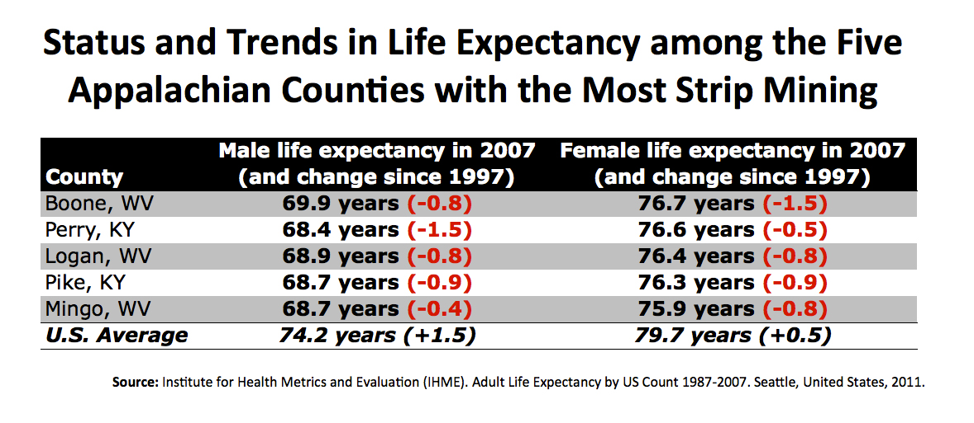

Mountaintop removal coal mining is also associated with poor emotional health. In surveys conducted by Gallup in 2010 across all 435 Congressional districts, those where mountaintop removal occurs ranked dead last in both physical and emotional well-being.

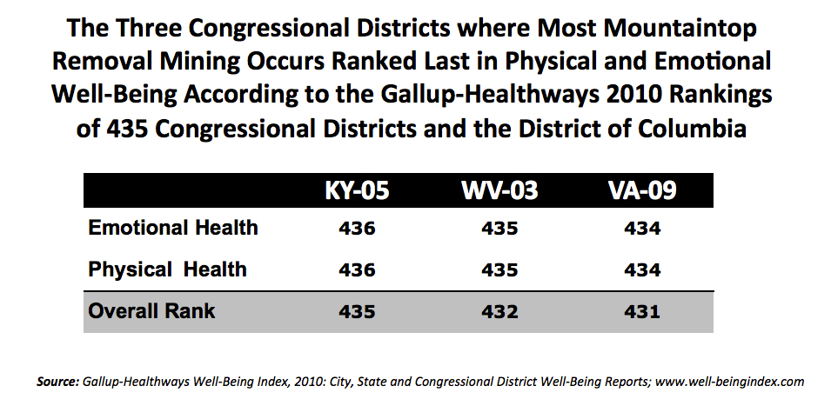
Given that mountaintop removal frequently forces Appalachians to leave homes and land that have been in their family for as many as five, six, or seven generations, severe impacts on emotional well-being are not surprising - it's not just mountains, streams, or even homes that are at stake, it's people's culture, identity and sense of place. These factors could also help explain the dramatic declines in population that have occurred over the past 30 years in counties where mountaintop removal occurs. The correlation between mountaintop removal mining and population declines is unmistakable in the map of county population trends between 1980 and 2010 shown below.

Beyond its association with poor physical and emotional health, mountaintop removal is associated just as strongly with poor socioeconomic conditions. Not only do the Central Appalachian counties where mountaintop removal occurs have among the highest poverty rates in the country, but a study of "persistent economic distress" published by the Appalachian Regional Commission in 2005 showed that those counties are far more likely to remain economically distressed compared to nearby counties where mining is less prevalent. According to the ARC study:

"Of all the regions in this analysis, Central Appalachia has been one of the poorest performers in relation to the ARC's economic distress measure over time. Furthermore, and unlike all other regions in the U.S., current and persistent economic distress within the Central Appalachian Region has been associated with employment in the mining industry, particularly coal mining."

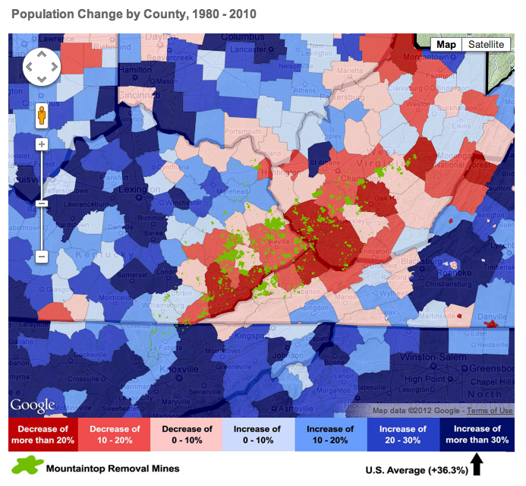

Ironically, the high poverty rates in Appalachian counties are frequently cited as reasons for streamlining the permitting of mountaintop removal mines, despite the fact that more than 50 years of poorly regulated strip mining has failed to improve the economic situation. A study published in 2011 in the Annals of the Association of American Geographers took on the question of the relationship between mountaintop removal and unemployment rates directly. Based on their analysis, the authors of the study concluded:

"Although policymakers are aware of the negative environmental effects of MTR, its continued use is primarily rationalized using the argument that it contributes to local economies, especially job retention and development... Contrary to pro-MTR arguments, we found no supporting evidence suggesting MTR contributed positively to nearby communities’ employment."

To make matters worse, a series of new studies that quantify coal-related revenues and expenditures to state treasuries have shown that the coal industries in West Virginia, Kentucky and Tennessee operate at a net loss to tax-payers, even accounting for the indirect impacts of coal mine employment while ignoring the "externalized costs" of the industry on the health and environment of communities where coal is mined. According to the West Virginia study:

"While every job and every dollar of revenue generated by the coal industry provides an economic benefit for the state of West Virginia and the counties where the coal is produced, the net impact of the West Virginia coal industry, when taking all revenues and expenditures into account, amounted to a net cost to the state of $97.5 million in Fiscal Year 2009."

One might wonder why, with all of the evidence that mountaintop removal has detrimental impacts on the health and well-being or nearby residents, the practice continues to occur and is supported by virtually every elected representative of the region to state and Congressional offices. The question becomes even more puzzling when one looks at recent polls showing that likely voters in Central Appalachian coal counties oppose the practice and, by an overwhelming margin, oppose the destruction and pollution of streams that results from mountaintop removal coal mining. According to a recent poll conducted by Lake Research Partners and Bellweather Research, "Voters across Kentucky, West Virginia, Tennessee, and Virginia solidly oppose mountaintop removal coal mining, by wide margins and across a host of demographic and political divides." The poll also found that:

- "Three-quarters support fully enforcing — and even increasing protections in — the Clean Water Act to safeguard streams, rivers, and lakes in their states from mountaintop removal coal mining... Just 8% of voters oppose it."
- "...fully 57% oppose mountaintop removal and with noticeable intensity (42% strongly oppose), compared to just 20% who support it (10% strongly)."
- "solid majorities of voters in these Appalachian states believe either that “environmental protections are often good for the economy” (40%) or “have little or no impact on the economy” (20%). Just one-quarter of voters (25%) believes that “environmental protections are often bad for the economy”."

How Will the Stream Protection Rule impact Jobs, Domestic Energy Production and the Price of Electricity?

Supporters of mountaintop removal mining like the National Mining Association have been issuing sky-is-falling predictions of devastating impacts on jobs and national security ever since the EPA announced its plans to give greater scrutiny to mountaintop removal mine permits in March of 2009. The industry sounded similar warnings when the memorandum of understanding was signed by EPA, OSM and the Army Corps of Engineers in June, 2009, and when EPA released a new guidance for reviewing Clean Water Act permits for Appalachian surface mines in April, 2010.

With three years of coal production and employment data now available since enhanced EPA oversight of mine permitting began, the validity of those predictions can be put to the test. Testing these claims should also shed some light on the validity and integrity of predictions now being made by those same companies and trade associations in regard to the Stream Protection Rule.

As it turns out, the prediction that EPA's actions would destroy jobs, increase electricity rates and put America's energy supply at risk not only failed to occur, but was precisely the opposite of what actually occurred. The discrepancy between coal industry predictions and reality is probably attributable to the fact that every statement and analysis that has been made by mountaintop removal supporters about the impact of more stringent mine permitting has been predicated on one common false assumption: that permits are the limiting factor for coal production and that simply permitting and developing new coal mines will increase overall production and employment. In reality, declining demand for coal is the bottleneck for production.

What coal industry representatives have consistently glossed over is the fact that demand for coal is declining across most of the U.S. for the simple reason that it is unable to compete with alternative sources of electricity generation. A story published by the Energy Information Administration in its Feb 29th edition of the "Electricity Monthly Update" provides a concise illustration of the point. The story is about how three natural gas plants in Ohio are supplying an increasing proportion of the state's electricity at the expense of seven older coal-fired plants that rely on Central Appalachian coal. According to the EIA:

"The increased generation from these three [gas-fired] plants is coming at the expense of less efficient coal plants. Seven coal plants in Ohio (with a combined capacity of 7,113 megawatts and an average heat rate around 10,500 Btu/kWh) have experienced a significant drop in generation in recent years. In the chart below, the generation share of these seven sample coal plants, expressed as its share of total generation from both sample coal and natural gas plants, is compared to the corresponding share of the three combined cycle plants. As illustrated in the chart, natural gas generation went from 3 percent of total sample plant generation in January 2008 to 47 percent in December 2011.

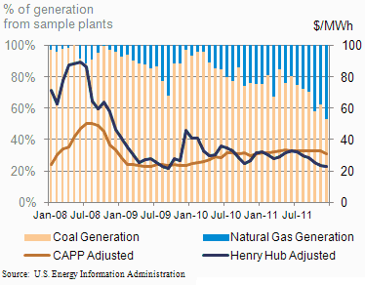

"As shown with the lines on the chart, relative Henry Hub and Central Appalachian coal prices appear to have a significant role in these gas-fired power plants being dispatched more often. The fuel prices have been adjusted to account for the average heat rate of natural gas or coal plants consuming that fuel in Ohio."

A similar story could be told in states all across the eastern U.S. that have traditionally relied on Appalachian coal. Across the region, natural gas prices have fallen below the level where Appalachian coal can compete. Moreover, the declining role of coal in U.S. electricity markets is not the result of any new regulations, but is the continuation of a decades-long trend that began in the mid 80s, when coal supplied nearly 60% of U.S electricity and is expected to continue at least through 2015, when EIA projects in its 2012 Annual Energy Outlook that coal will account for just 39% of U.S. generation.

No impact of previous EPA and OSM actions on jobs

In contrast to the dire predictions from mountaintop removal supporters, the number of mining jobs in Appalachia has increased substantially since 2009. In fact, 2011 saw the highest level of employment at Appalachian coal mines since 1997. Employment in the 4th quarter of 2011 was up 6% since the MOU was signed in June, 2009, and it was up 9% since EPA issued a new guidance on surface mine permitting in April, 2010 (see chart on next page).
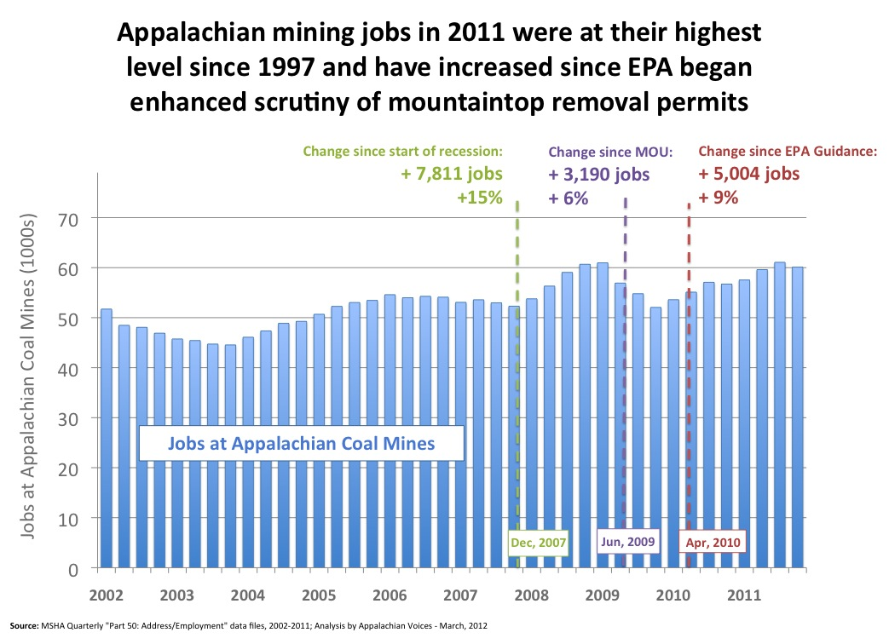

Of course, if demand for Appalachian coal continues on its expected downward trajectory then the number of jobs will ultimately decline as well. In fact, it appears that may already be occurring, as the enormous surge in international demand for metallurgical coal that began in 2009, which partially compensated for the sharp drop in demand for thermal coal from domestic power producers, has begun to fall off. As a result, Appalachian coal production is down 8% compared to the first quarter of 2011 and an increasing number of layoffs have occurred recently due to companies' decisions to idle or curtail production at certain mines. The fact that these layoffs are the result of falling demand, as opposed to difficulty in obtaining mining permits, is demonstrated by a press release issued by Alpha Natural Resources in February announcing their intention to idle six Appalachian mines and reduce production at four others. Alpha's CEO Kevin Crutchfield explained in the press release that "Several mines are encountering weak demand for their products," and that "... adverse market conditions left us no choice."

The press release goes on to explain that "Alpha's Central Appalachian businesses are seeing more electric utilities switch from thermal coal to natural gas to take advantage of gas prices at 10-year lows." The company also attributes some of the drop in demand to the fact that utilities are "shutting down a number of generating stations that have traditionally run on coals sourced from Central Appalachia."

No impact of previous EPA and OSM actions on energy supply and electricity prices

According to the Federal Reserve, the productive capacity of actively producing coal mines in the U.S. in 2011 was the highest it has ever been since they began supplying such estimates in 1986. The Fed estimates that productive capacity increased by 1.6% since 2009, when more stringent review of Appalachian mine permits began. The Federal Reserve data also show that the utilization of the productive capacity of active U.S. coal mines was an anemic 77% in 2011 - the lowest it's been since the Fed began supplying such estimates. The capacity utilization of U.S. mines has averaged 85% since 1986.

To put those numbers in perspective, mines that have already been permitted could have produced an additional 138 million tons in 2011 if they were operating at the historic average level of capacity utilization. Notably, that is somewhat more than the 119 million tons produced by all strip mines in Appalachia combined. There could be no clearer evidence that the reason U.S. mines are operating at such a low capacity is because there is insufficient demand for the coal they could produce, and has nothing to do with difficulties companies might face in obtaining new permits for mountaintop removal mines.

Finally, an update on natural gas supplies in the Federal Energy Regulatory Commission's recent "Winter Market Assessment" highlights the absurdity of any contention that permitting requirements for mountaintop removal coal mines threaten national security and domestic energy supply. In their report, FERC makes clear that natural gas supplies are likely to remain more than adequate for two reasons: the rapid increase in unconventional gas drilling in the Marcellus Shale and the enormous increase in domestic oil drilling resulting from high oil prices. According to FERC:

"Natural gas production continued to grow in 2011, setting records throughout the year ... Shale gas now accounts for more than 25% of U.S. production, up from 5% in 2007. There has also been an increase in production of associated gas from oil shale wells, as high oil prices led to the acceleration in drilling for shale oil... In some regions, the rush to extract oil from oil rich shale formations has also resulted in high levels of flaring, or burning of natural gas. In the Bakken shale formation in North Dakota, for example, the natural gas gathering system is struggling to keep pace with growing production, and an estimated 25% of the natural gas produced, as much as 100 MMcfd, has been flared this year."

In regard to electricity rates, the average retail cost of electricity across the U.S. has increased by 1.7% since 2009, when the MOU on mountaintop removal went into effect. That translates into an annual rate of increase of less than 1% - below the rate of inflation. More importantly, the price of electricity in the South Atlantic - the region where most Central Appalachian coal is consumed - has actually fallen by 0.6% since 2009.

Predictions of the impact of the Stream Protection Rule are based on faulty assumptions and non-existent data

The most important thing to understand about any prediction of economic impacts of the Stream Protection rule is that, at this point, there is simply nothing valid to base those predictions on. OSM hasn't even proposed a draft rule. In the mean time, studies based on unrealistic assumptions and worst-case scenarios only serve to obfuscate the important issues the rule is designed to address.

Some studies claim to be based on an early version of the draft EIS for the rule that was leaked to coal companies and the media last year. The EIS analyzed 5 different alternatives that included "no action" (Alternative 1), three regulatory approaches presented in descending order of their relative impact on current mining practices (Alternatives 2,3 and 4), and a hybrid that was identified as OSM's preferred approach (Alternative 5). Even assuming that these alternatives are representative of OSM’s current thinking, however, the analyses released by industry groups have no relationship to the actual content of the document that was leaked and appear to be based on data that was simply made up.

Even the original analysis conducted by the contractors that produced the draft EIS was problematic, as it was based on demonstrably unrealistic assumptions of coal demand. For instance, the headline in the media - that 7,000 jobs in Appalachia are projected to be lost if OSM's "preferred alternative" were implemented - was based on the assumption that demand for Appalachian coal would remain roughly constant at 2008 levels. As a result, the production levels at Appalachian mines that were forecast under all five regulatory scenarios were higher than what the Energy Information Administration is forecasting in its 2012 Annual Energy Outlook (see figure below).

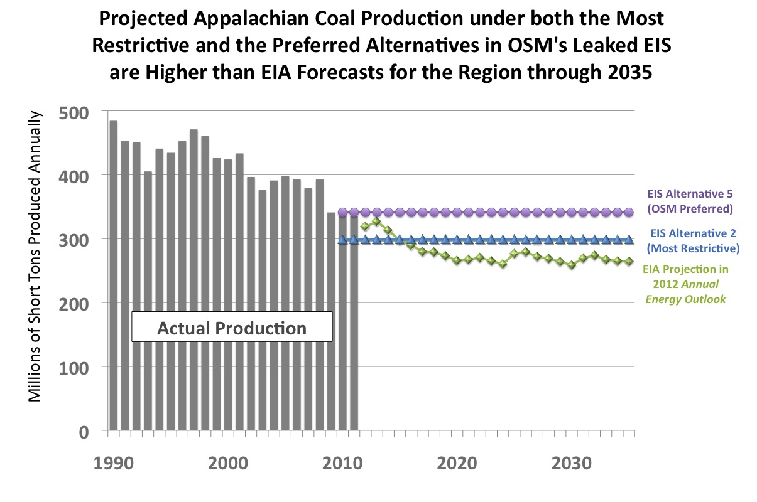

In other words, if the same analysis were applied to more realistic levels of coal demand it would presumable predict there would be no reduction in Appalachian coal production and employment under any of the alternative rules considered in the EIS.

Conclusion

Starving OSM of the funds it needs to promulgate the Stream Protection Rule would be irresponsible and it would be unethical given the enormous amount of evidence in recent peer-reviewed scientific literature showing that poorly regulated mining is causing irreparable damage to streams that are the headwaters of the drinking water supply of millions of Americans, and is the key factor implicated in what amounts to a public health crisis in Appalachia.

In terms of EPA's and OSM's actions around mountaintop removal, many environmental and Appalachian community advocates are also concerned about the approach these agencies are taking, but for very different reasons than those of the coal industry representatives that have testified repeatedly to this committee. I believe that EPA and OSM have erred in vainly pursuing a coherent approach to regulating mountaintop removal coal mining because mountaintop removal simply can't be done in a manner that complies with the Clean Water Act, much less that protects the health and welfare of people living nearby. Mountaintop removal doesn't need to be regulated, it needs to be ended. Even if there were an economic justification for neglecting clean water safeguards and the welfare of the Appalachian people, every rationale that has been put forward to continue mountaintop removal is contradicted by readily available facts which I have provided throughout this testimony.

I thank the committee and Chairman Lamborn again for the opportunity to speak on behalf of the thousands of people suffering from the impacts of poorly regulated coal mining practices. I sincerely hope that my testimony will help this committee better understand the pressing need for OSM to develop an effective set of rules to ensure that coal mining can continue to supply our country with much needed energy without the devastating impacts to public health, the environment and the economy of the regions where coal is mined.

REFERENCES

Palmer, M.S., E. S. Bernhardt, W. H. Schlesinger, K. N. Eshleman, E. Foufoula-Georgiou, M. S. Hendryx, A. D. Lemly, G. E. Likens, O. L. Loucks, M. E. Power, P. S. White, P. R. Wilcock. (2010) “Mountaintop Mining Consequences.” Science, 327: 148-9.

Zullig, KJ. and M. Hendryx.(2011) “Health-Related Quality of Life Among Central Appalachian Residents in Mountaintop Mining Counties.” American Journal of Public Health 101, 5 (2011): 848-53.

Hendryx, M. (2011) “Poverty and Mortality Disparities in Central Appalachia: Mountaintop Mining and Environmental Justice.” Journal of Health Disparities Research and Practice: Vol 4 (3) pp 44-53.

Esch, L. and M. Hendryx. (2011) “Chronic Cardiovascular Disease Mortality in Mountaintop Mining Areas of Central Appalachian States.” Journal of Rural Health.

Hendryx, M., L. Wolfe, J. Luo, and B. Webb. (2011) “Self-Reported Cancer Rates in Two Rural Areas of West Virginia with and without Mountaintop Coal Mining.” Journal of Community Health.

Epstein, P., J. Buonocore, K. Eckerle, M. Hendryx, B. M. Stout III, R. Heinberg, R. W. Clapp, B. May, N. L. Reinhart, M. M. Ahern, S. K. Doshi, and L. Glustrom. (2011) “Full cost accounting for the life cycle of coal.” Annals of the New York Academy of Sciences 1219: 73-98.

Hitt N, Hendryx M, Ecological integrity of streams related to human cancer mortality rates, Eco health 7, 91-104, 2010.

Ahern, M., M. Mullett, K. MacKay and C. Hamilton. (2010) “Residence in Coal-Mining Areas and Low Birth Weight Outcomes.” Maternal Child Health, Jan 2010.

Hendryx, M., E. Fedorko, and A. Anesetti-Rotherme. (2010) “A Geographical Information System-Based Analysis of Cancer Mortality and Population Exposure to Coal Mining Activities in West Virginia.” Geospatial Health 4(2), 2010

Zullig, K., and M. Hendryx. (2010) “A Comparative Analysis of Health-Related Quality of Life for Residents of U.S.Counties with and without Coal Mining.” Public Health Reports, Volume 125

Hendryx, M. (2009) “Mortality from heart, respiratory, and kidney disease in coal mining areas of Appalachia.” International Archives of Occupational and Environmental Health: 82: 243-49.

Hendryx, M. (2009) “Mortality in Appalachian Coal Mining Regions: The Value of Statistical Life Lost.” Public Health Reports: 124: 541-50

West Virginians for Affordable Health Care. (2008) Early Deaths: West Virginians Have Some of the Shortest Life Expectancies in the United States.

Hendryx, M. (2008) “Relations Between Health Indicators and Residential Proximity to Coal Mining in West Virginia.” American Journal of Public Health, 98: 669-71.

Hendryx, M., K. O’Donnell and K. Horn. (2008) “Lung cancer mortality is elevated in coal-mining areas of Appalachia” Lung Cancer: 62: 1-7.

Hendryx, M. (2008) “Mortality rates in Appalachian coal mining counties: 24 years behind the nation”. Environmental Justice: 1, 1: 5-11.

Hendryx, M., M. Ahern, and T. Nurkiewicz. (2011) “Hospitalization Patterns Associated with Appalachian Coal Mining.” Journal of Toxicology and Environmental Health, Part A, 70: 2064-70.

Kulkarni, SC., A. Levin-Rector, M. Ezzati and C. Murray. “Falling behind: life expectancy in US counties from 2000 to 2007 in an international context.” Population Health Metrics: 9(2011): 16.

Woods, B. R. and J. S. Gordon, 2011. "Mountaintop Removal and Job Creation: Exploring the Relationship Using Spatial Regression," Annals of the Association of American Geographers Volume 101, Issue 4: 806-815.

Wood, L. E. 2005, "Trends in National and Regional Economic Distress: 1960‐2000" Prepared for the Appalachian Regional Commission, April 2005.

"The Impact of Coal on the Kentucky State Budget" by Melissa Fry Konty and Jason Bailey. A report by the Mountain Association for Community Economic Development published on June 25, 2009

"The Impact of Coal on the West Virginia State Budget" by Rory McIlmoil and Evan Hansen of Downstream Strategies and Ted Boettner and Paul Miller of the West Virginia Center on Budget and Policy. June 22, 2010.

"The Impact of Coal on the Tennessee State Budget" by Rory McIlmoil and Evan Hansen of Downstream Strategies and Ted Boettner of the West Virginia Center on Budget and Policy. June 22, 2010.

Gallup-Healthways Well-Being Index, 2010: City, State and Congressional District Well-Being Reports; www.well-beingindex.com.

FERC Report on Natural Gas Supplies
"Winter 2011-12 Energy Market Assessment: Item No A-3," a presentation published by the Federal Energy Regulatory Commission on 20 October, 2011.

Opinion Poll on Voter Attitudes about Mountaintop Removal:
http://www.appalmad.org/slider/new-poll-shows-widespread-support-for-clean-water-act/

