Appalachian Coal Jobs Update -- June, 2012

Consumption of coal at U.S. electric generating plants has declined sharply in the first three months of 2012, leading to production cuts at mines across the country and announcements of layoffs and mine closures by some major Appalachian producers. Coal industry supporters and critics of the Obama Administration have been quick to attribute these layoffs to actions the Environmental Protection Agency (EPA) has recently taken to reduce emissions of mercury and greenhouse gases from coal-fired power plants and to reduce the impacts of surface coal mining on headwater streams in Appalachia. It is now du rigeur for Appalachian politicians to claim that EPA's actions amount to a “war on coal” that is threatening jobs and the economy in the region.

In contrast to the pervasive "war on coal" rhetoric, recently released data from the Energy Information Administration (EIA) and the Mine Safety and Health Administration (MSHA) provide no evidence that EPA actions are leading to job losses in the Appalachian coal industry. In 2011, the number of coal mining jobs in Appalachia reached its highest level since 1997 despite a dramatic decline in the use of coal in favor of less expensive natural gas for electricity generation over the same period. Notably, employment was up 6% since the Obama Administration announced more stringent “Enhanced Coordination Procedures” for permitting of mountaintop removal mines in June, 2009.

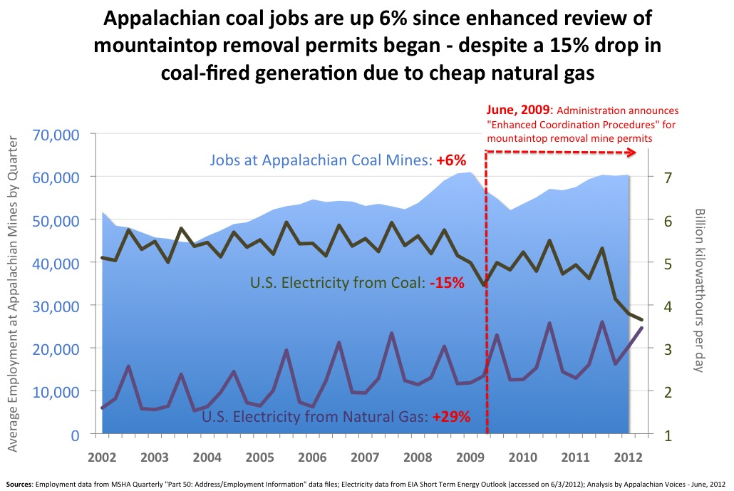

Data for the first quarter of 2012 may paint an overly rosy picture of the current state of coal mining, however, because major declines in employment typically lag behind declines in demand by 3-6 months (i.e., mine employment following the recession-related crash in coal demand in the first quarter of 2009 did not bottom out until the 3rd quarter). In fact, a survey of recent news reports by Ken Ward Jr. at the Charleston Gazette¹ and by Appalachian Voices staff indicate there have been at least 600 planned layoffs in West Virginia and 900 in Kentucky reported in news media since March that may not be represented in the 1st quarter MSHA figures. Moreover, EIA projects that natural gas will continue to displace coal for electricity generation at high levels for at least the next two years², so there can be little doubt that low coal demand will continue to require production cuts and closures of the highest-cost mines in Appalachia in the months ahead.

While layoffs are occurring and may be accelerating, there is no evidence that EPA rules are costing responsible. For instance, every coal company announcement of a mass layoff or mine closure this year in Kentucky has cited poor market conditions as the reason for the action. None have cited difficulties obtaining a Clean Water Act permit (see below).

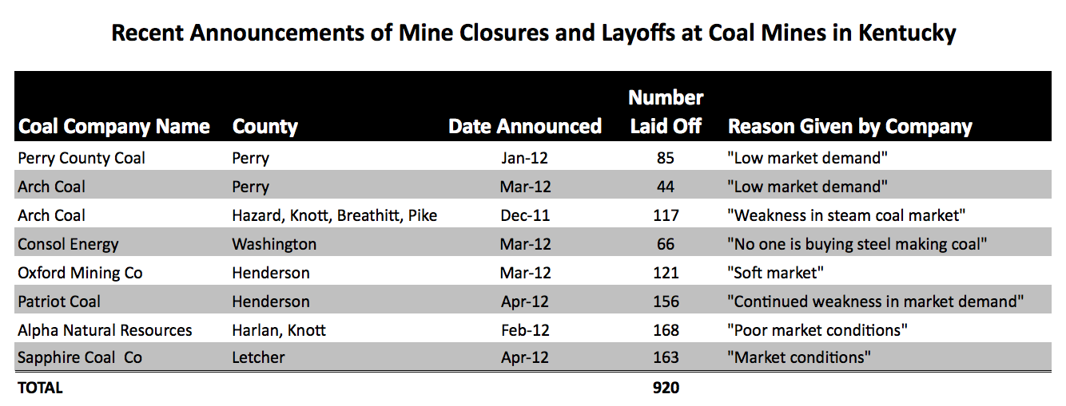

Despite the lack of statistical evidence suggesting that EPA's enhanced oversight of Clean Water Act permitting in Appalachia has led to a net increase in layoffs and mine closures, there are of course anecdotes of individual mines that have been unable to obtain the required Clean Water Act permits. It is these anecdotes that provide the basis for the narrative that EPA regulations are "killing jobs" -- a narrative that is bolstered by studies that attempt to tally or predict job losses that result from regulations on mining^{3,4}. Every one of the studies commonly used to support the "job-killing regulations" narrative has been based on the same logical fallacy, however: they assume that permits are the limiting factor for coal production. In other words, they tacitly assume that if a mine is permitted, there will be a proportional increase in coal demand such that the coal that it produces will not displace production (and jobs) at another mine.

In reality, plummeting demand for thermal coal and limited storage capacity necessitate production cuts at mines somewhere, regardless of the permitting actions of regulators. In that context, EPA's actions on mine permitting simply serve only to ensure that a greater proportion of production cuts occur at mines that have significant adverse impacts on the environment and communities in coal mining regions. In the absence of EPA's actions to protect water quality, a similar amount of production would be cut, but the most responsible operators that try to minimize water quality impacts and maximize mine safety would bear a greater share of those cuts rather than irresponsible operators that cut corners in order to lower costs.

The other argument used to blame EPA for mine layoffs is that regulations on mine discharge, smokestack emissions and coal ash disposal have an additive impact on the cost of producing electricity from coal, putting coal at a relative disadvantage to other fuel options. There is no debate about the validity of this dynamic in general, although there is much debate about whether making coal companies more accountable for their pollution amounts to a "war on coal" or represents a common sense effort to protect air, water and public health from pollution that is currently "externalized" onto the public by an industry that refuses to pay for its own waste.

Regardless, any utility that is able to replace electricity from plants burning Appalachian coal with electricity from its natural gas plants should already be doing so, as the delivered cost of Appalachian coal averages in the range of $3.00-$4.00 per million Btu (and the higher heat rates of coal plants mean they have to burn as much as 50% more Btus per kWh of electricity they produce)⁵. The only plants still consuming Appalachian coal are doing so because their operators do not have sufficient capacity at natural gas plants (or plants designed to burn lower cost mid-western and western coals) to replace the high-cost generation from plants dependent on Appalachian coal. Because these plants are "captive" to Appalachian coal, the price they are paying for it has little if any impact on the amount they consume.

Another line of evidence also refutes the claim that EPA regulations are driving job losses in Appalachia: if higher costs resulting from stronger enforcement of the clean air and clean water laws were driving the displacement of Appalachian coal by other fuels, then the retail cost of electricity should be rising in the region where Appalachian coal is being displaced. Otherwise, the displacement of coal by natural gas is better explained by what has often been called "the invisible hand of the market." Indeed, critics of the EPA have been warning about higher electric rates ever since the agency first announced more stringent review of mountaintop removal permits in June, 2009. In contrast to the emphatic warnings of coal companies and their allies, however, retail electricity rates have declined by 2% since June, 2009, including in the regions of the country most dependent on Appalachian coal.

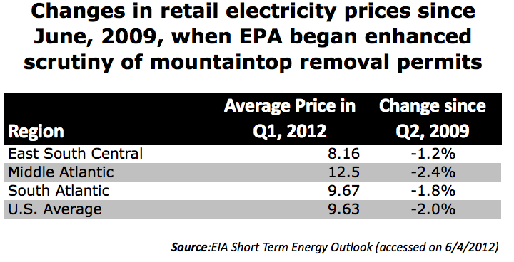
Why have natural gas prices declined so precipitously?

According to the EIA the sharp decline in coal consumption in the first quarter of 2012 was the result of extraordinarily low natural gas prices combined with a mild winter across much of the continent. The Federal Energy Regulatory Commission states in its recent "Winter Market Assessment” that natural gas production is high – and likely to remain high -- for two reasons: the rapid increase in unconventional gas drilling in the Marcellus Shale and the enormous increase in domestic oil drilling resulting from high oil prices⁶. According to FERC:

"Natural gas production continued to grow in 2011, setting records throughout the year ... Shale gas now accounts for more than 25% of U.S. production, up from 5% in 2007. There has also been an increase in production of associated gas from oil shale wells, as high oil prices led to the acceleration in drilling for shale oil... In some regions, the rush to extract oil from oil rich shale formations has also resulted in high levels of flaring, or burning of natural gas.”

While EIA expects natural gas prices to recover from recent lows by next year, they project prices will still be in the $3.00-$3.50 per million Btu range² - a price against which few if any Appalachian coal producers can compete when transportation costs and the lower efficiency of coal plants are taken into account. As such, it's unlikely that the market share for thermal coal from Appalachia will grow beyond where it is now for at least the next few years.

Implications for job creation in Appalachian states

While the recent high level of displacement of Appalachian coal demand by natural gas could be a temporary phenomenon, the gradual erosion of coal’s share of the domestic electricity market is not – the proportion of electricity generated from coal has declined steadily from its high of nearly 60% in the late 1980s.

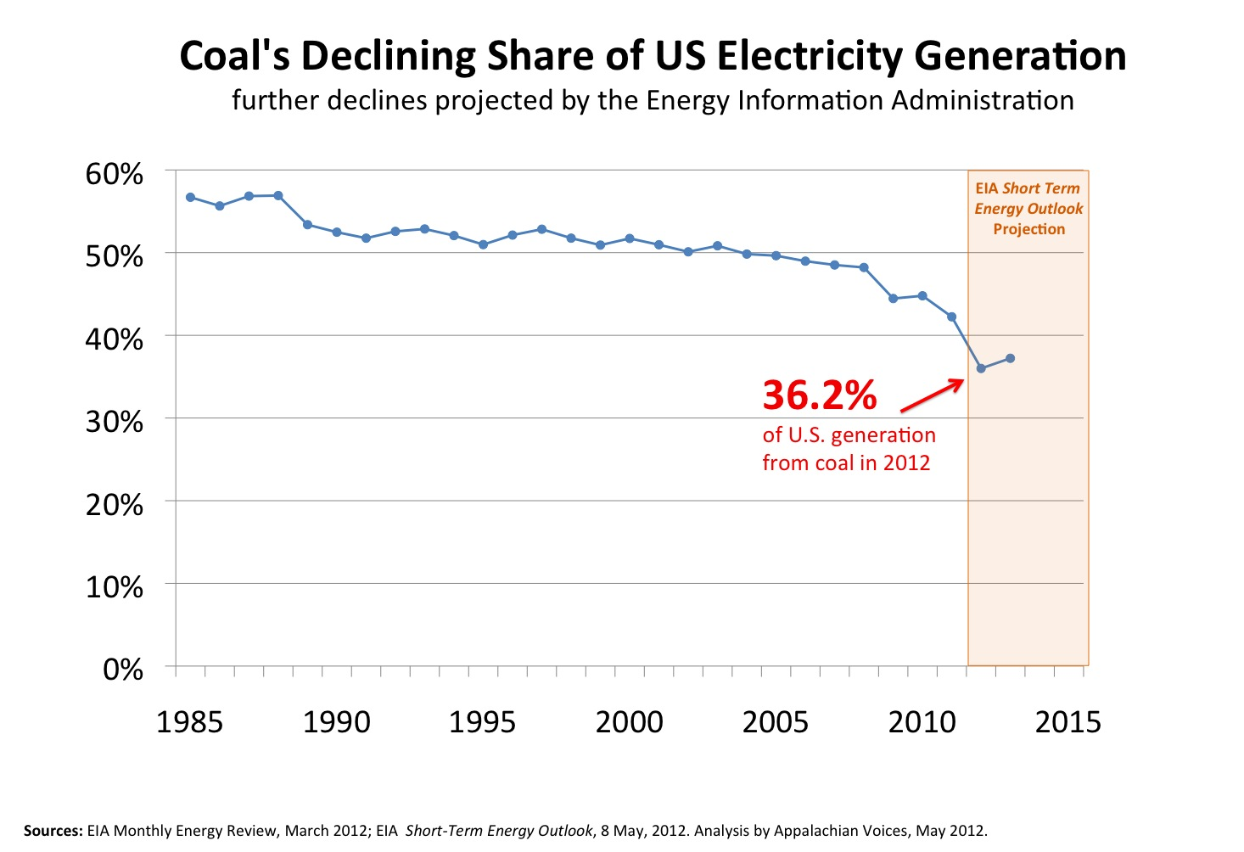
This trend was not the result of dramatic policy changes, but rather competition from other energy sources as new developments in drilling technology have made natural gas more competitive, companies have found ways to maximize the capacity utilization of existing nuclear generators, and the cost of some renewable energy technologies - particularly wind - have become competitive with coal. At the same time, coal mining companies have seen their costs increase as the highest quality and easiest to access seams of coal have been depleted and the remaining seams become more difficult, expensive and dangerous to access with every passing year⁷. The productivity of Appalachian mines (tons produced per miner-hour) peaked in the early 2000s and has declined sharply over the last decade. As a result of all of these factors, EIA projects coal's historic cost advantage will continue to erode in the future, even in the absence of new environmental or climate policy⁸. Thus, there appears to be little prospect that a surge in thermal coal demand for electricity production could create significant job growth in the Appalachian coal industry in the foreseeable future, regardless of what the EPA does.

On the other hand, the ability of the Appalachian coal industry to weather the recent massive drop in demand for thermal coal with relatively few layoffs indicates that captive demand for Appalachian thermal coal combined with burgeoning demand for metallurgical coal could be sufficient to prevent a major employment crisis in the near term, even as the use of coal for electricity continues its gradual decline. An important factor is the fact that metallurgical coal is selling on the international market at $150/ton or more⁹ -- prices that can support the continuing expansion of mine payrolls that will be required to mine depleted and difficult to access Appalachian coal seams as mining conditions continue to deteriorate in the future. Thus, predictions of economic ruin from the decline of the coal industry in Appalachia on all sides of the debate may well be overblown. While the prospects for economic renewal based on a resurgence of the coal industry in Appalachia appear dim, the slow rate of decline in coal mining jobs offers policy-makers some breathing room to engage in the difficult and gradual process of diversifying the economy of coal-dependent communities and seek to attract new industries to the region.

Not every Appalachian state is equally well positioned to withstand an extended decline in coal demand, however, as some are dependent on thermal coal sales to domestic power plants while others have greater exposure to international markets and metallurgical coal buyers. Virginia represents the better-positioned end of the risk spectrum, while East Kentucky is an example of a state that is poorly positioned because nearly all of its coal sales are to U.S. power plants. By contrast, only 37% of Virginia's coal sales depend on that market, while nearly half of its sales are to coking plants and the burgeoning international coal market (see charts on next page).

This difference in exposure to the volatile electric power market helps explain differences in how mine employment has changed in Appalachian states over the past few years. Virginia, for instance, has seen exceedingly positive trends, with employment up by 18% since the EPA began enhanced review of mountaintop removal permits and up 28% since the start of the recession in December, 2007. Employment at Kentucky mines, while it is up 9% since the start of the last recession, is actually down by 5% since June of 2009.

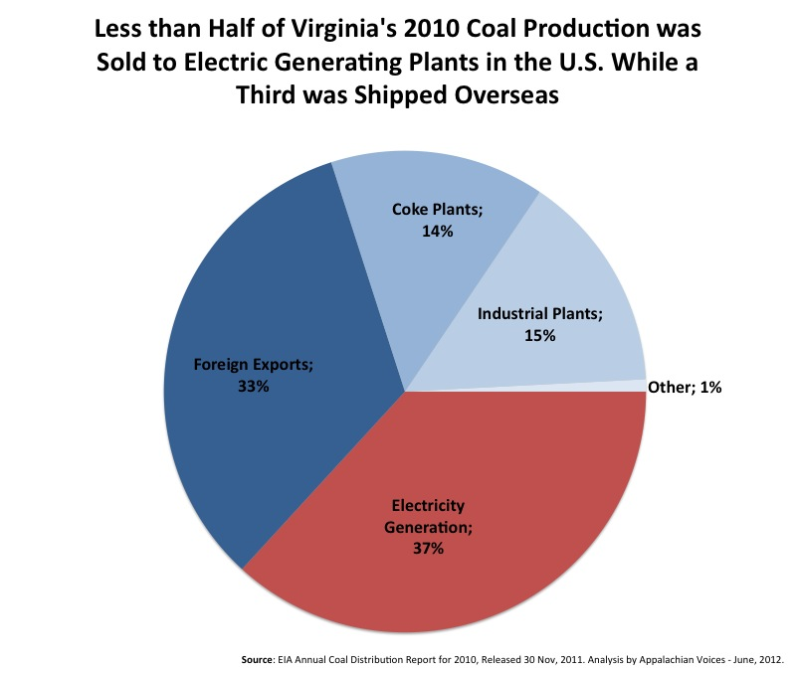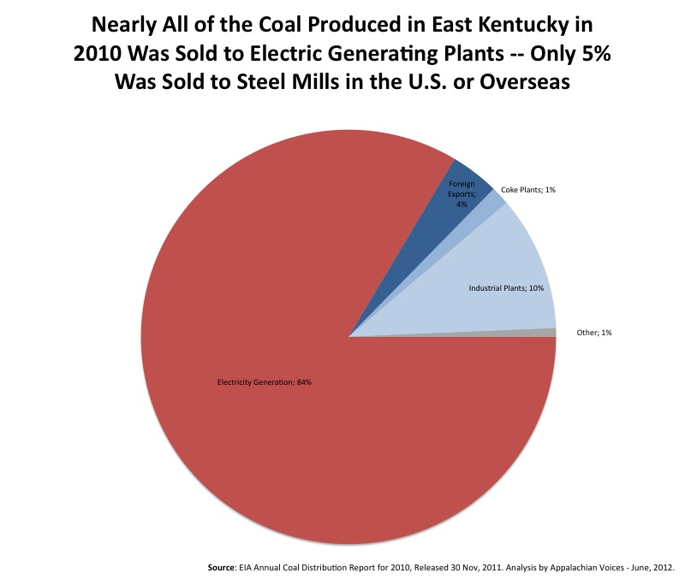

The difference between Virginia's experience and Kentucky's illustrates how recent employment trends have been driven by changing electricity markets and not EPA oversight of Clean Water Act permits, which applies to mines producing thermal coal and those producing metallurgical coal alike.

Given the likelihood of continued erosion of coal's share of electricity markets, it's particularly important that states like Kentucky make economic transition and diversification initiatives in coal regions an immediate priority. Fighting with the EPA over permitting of mountaintop removal mines, on the other hand, is likely not a battle that is worth winning for Kentucky decision-makers concerned about creating and maintaining jobs in the state: there is little evidence or rational basis to believe that EPA's actions will have a measurable impact.

Citations:

1. ‘Banning cars that fly’: Coal faces the market; May 21, 2012 by Ken Ward Jr. (URL: http://blogs.wvgazette.com/coaltattoo/)
2. EIA Short Term Energy Outlook, published May 8, 2012 (URL: http://www.eia.gov/forecasts/steo/)
3. “The Obama Administration’s Obstruction of Coal Mine Permits in Appalachia,” a report by the minotrity staff of the Senate Environment and Public Works Committee, May 21, 2010.
4. ENVIRON, 2012, “Economic Analysis of Proposed Stream Protection Rule.” May 5th, 2012
5. EIA Annual Coal Report for 2010, Released September, 2011 (DOE/EIA-0584)
6. "Winter 2011-12 Energy Market Assessment: Item No A-3," a presentation published by the Federal Energy Regulatory Commission on 20 October, 2011.
7. “Coal: Research and Development to Support National Energy Policy,” National Academies Press, 2007
8. EIA Annual Energy Outlook 2012, Early Release Edition.
9. EIA Quarterly Coal Report, October-December, 2011; released 18 April, 2012.

